CS Bridge Module 14 Sorting

1. Sorting Problem Definition

1.1 CS Bridge: Sorting
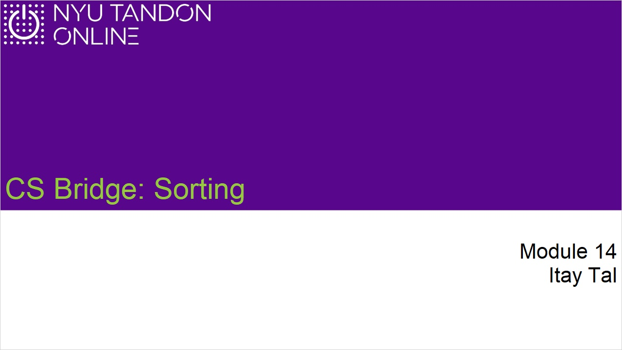

1.2 The Sorting Problem
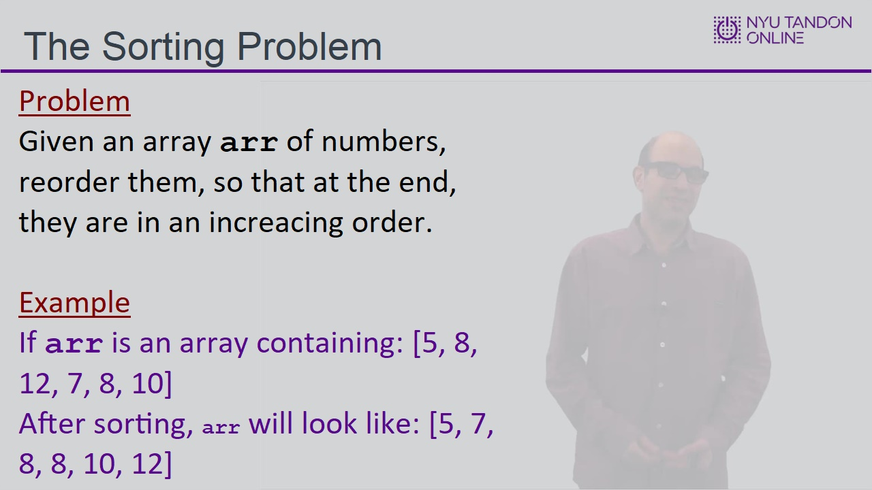

1.3 Sorting Algorithms
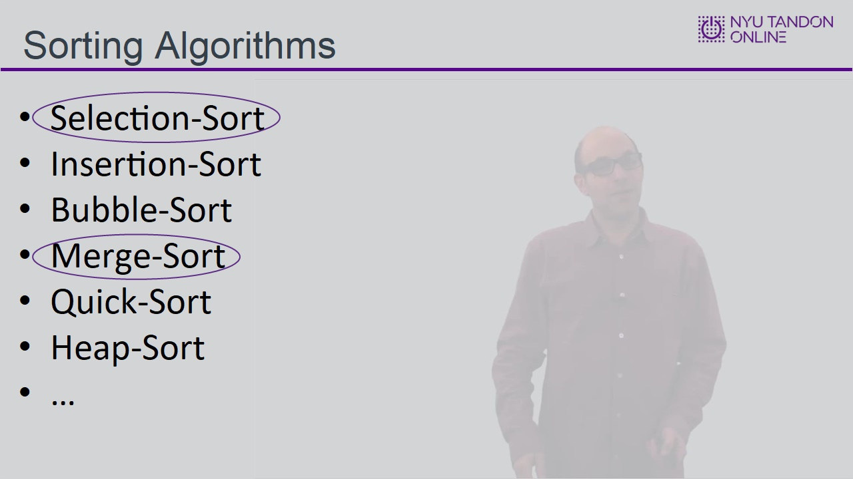

2. Selection Sort

2.1 Selection Sort
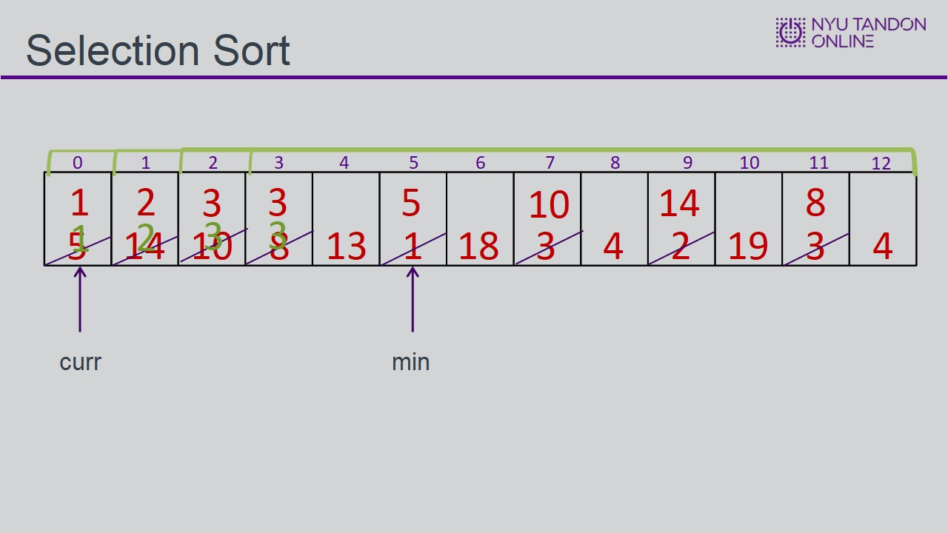

2.2 Selection Sort Implementation
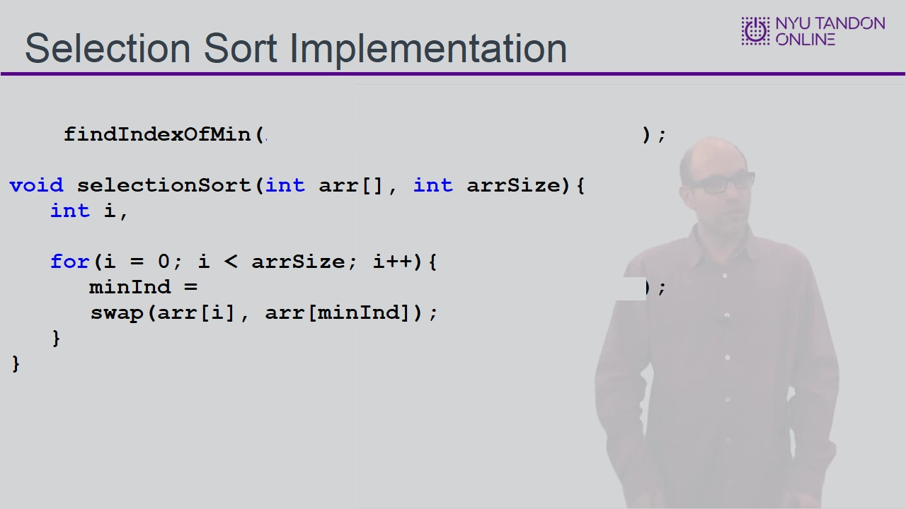

2.3 Selection Sort Implementation
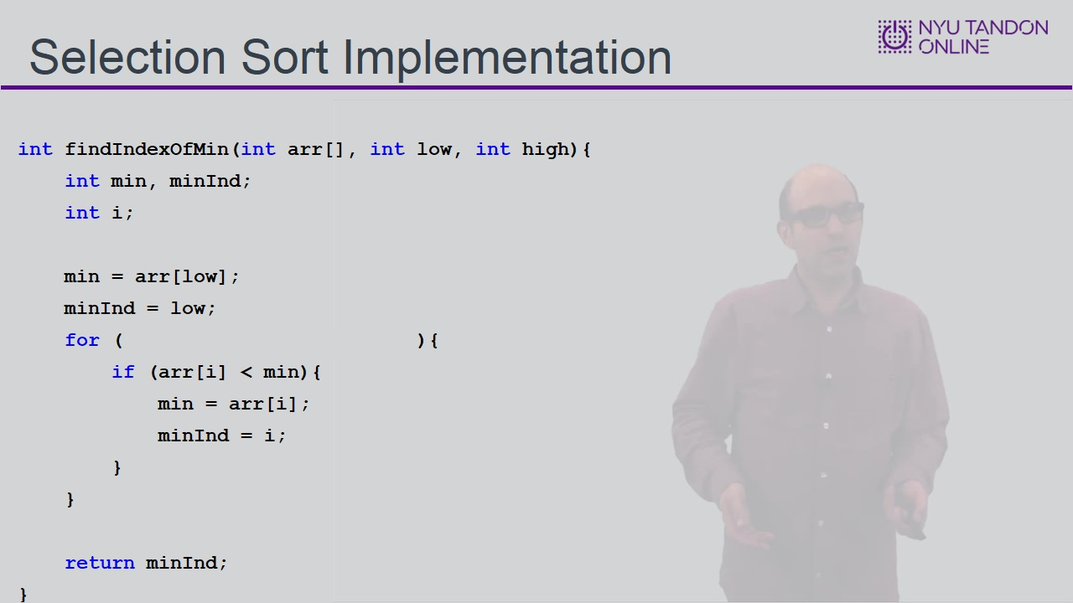

2.4 Runtime Analysis
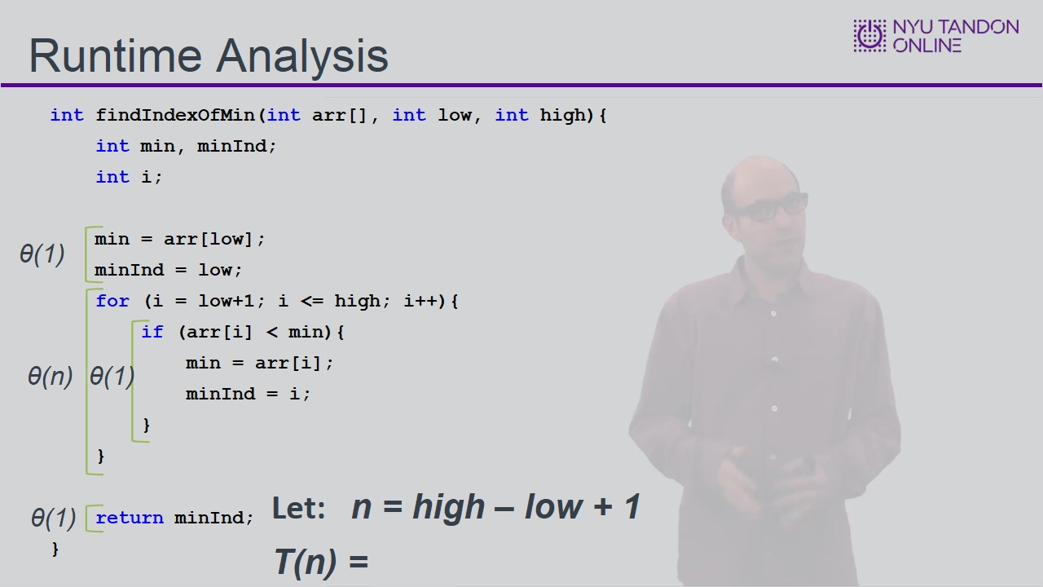

2.5 Runtime Analysis
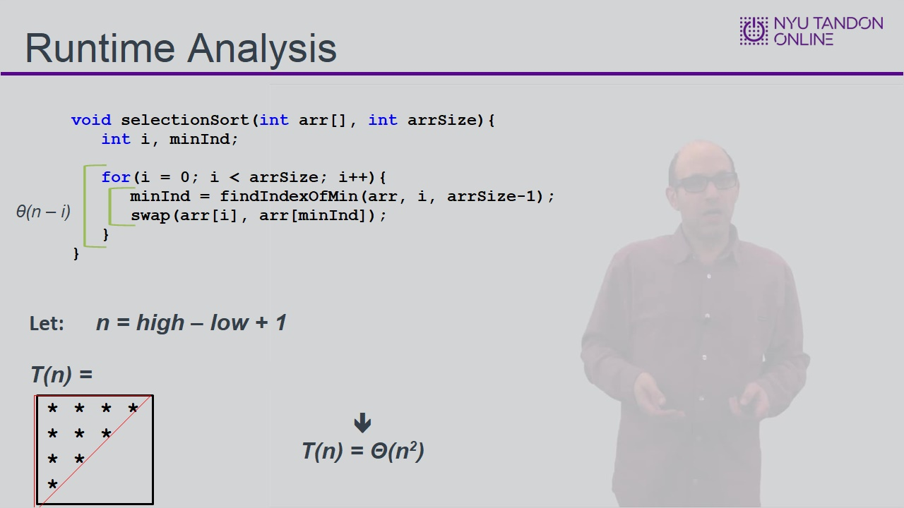

3. Merge Sort

3.1 Merge Sort
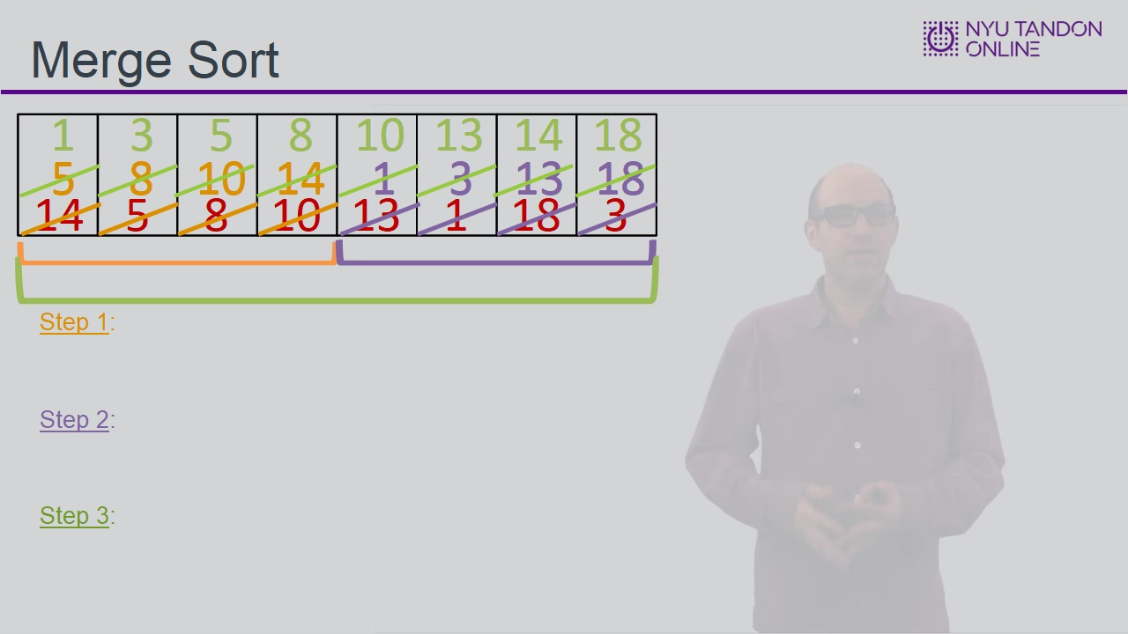
Notes:

3.2 Implementation
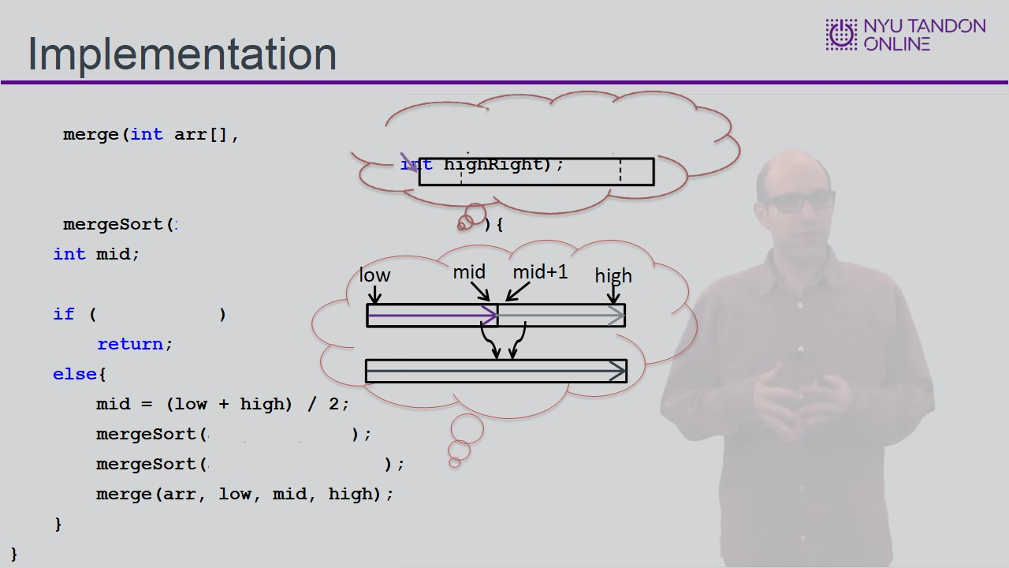

3.3 Merge Sort
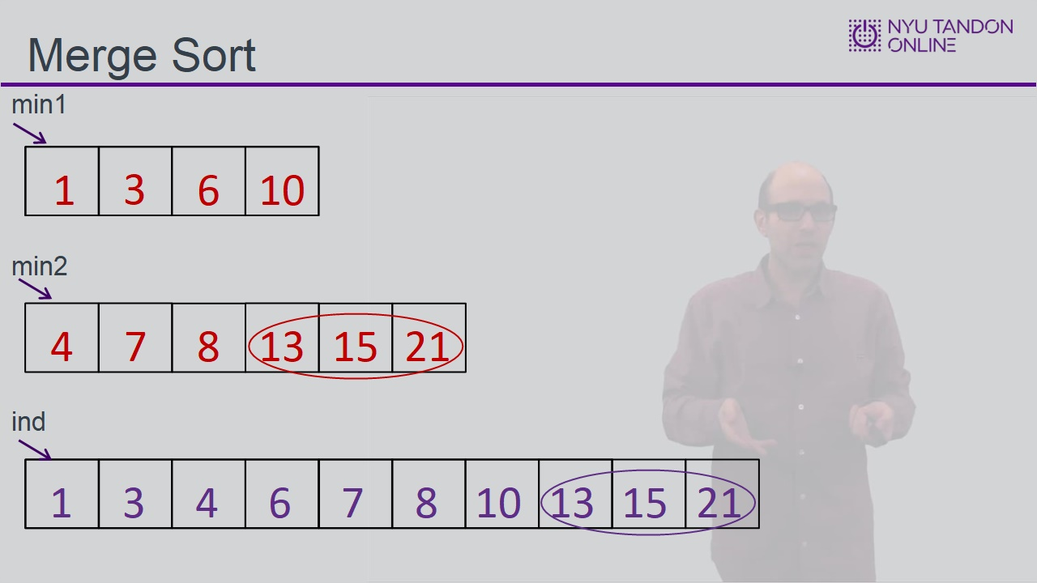
Notes:

3.4 Merge Sort Implementation
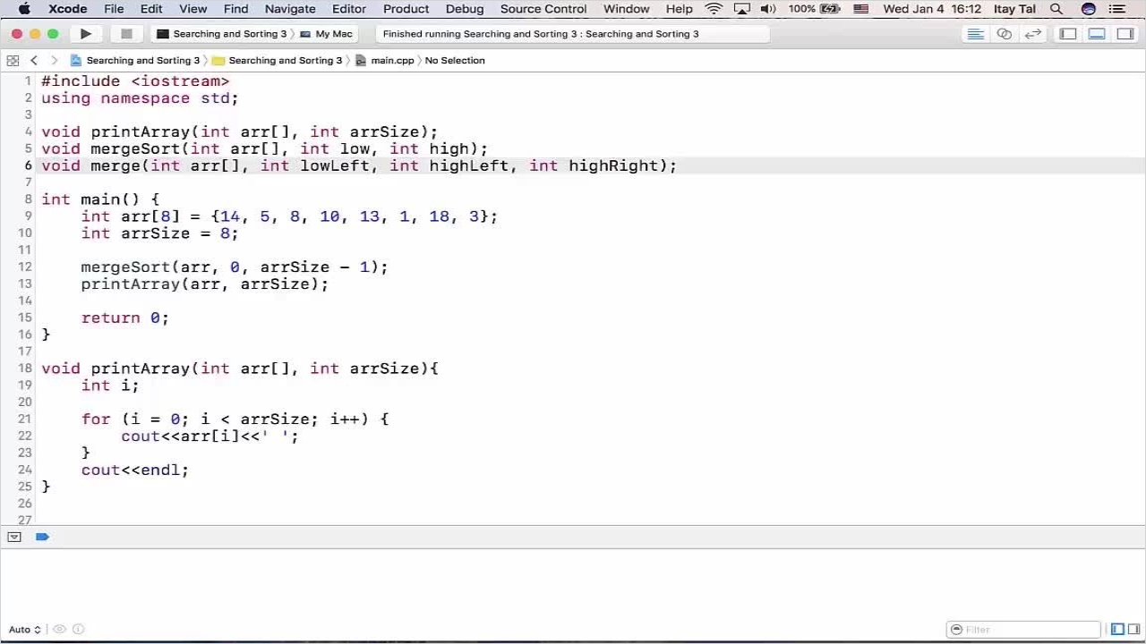

3.5 Tracing Merge Sort Execution
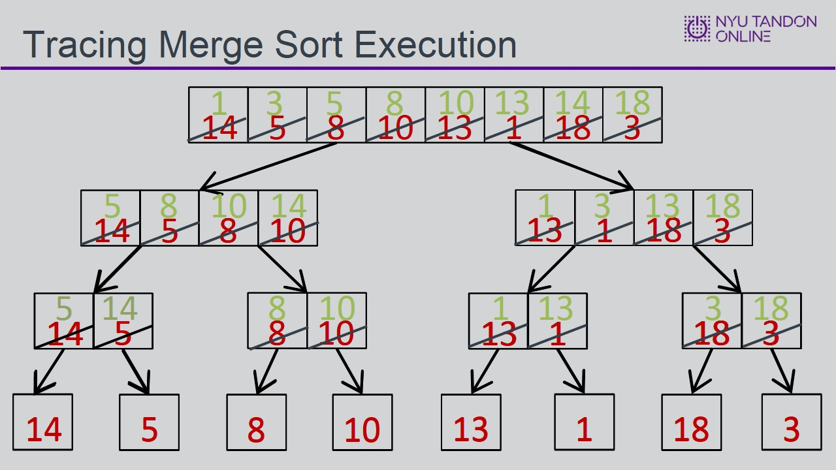

3.6 Runtime Analysis
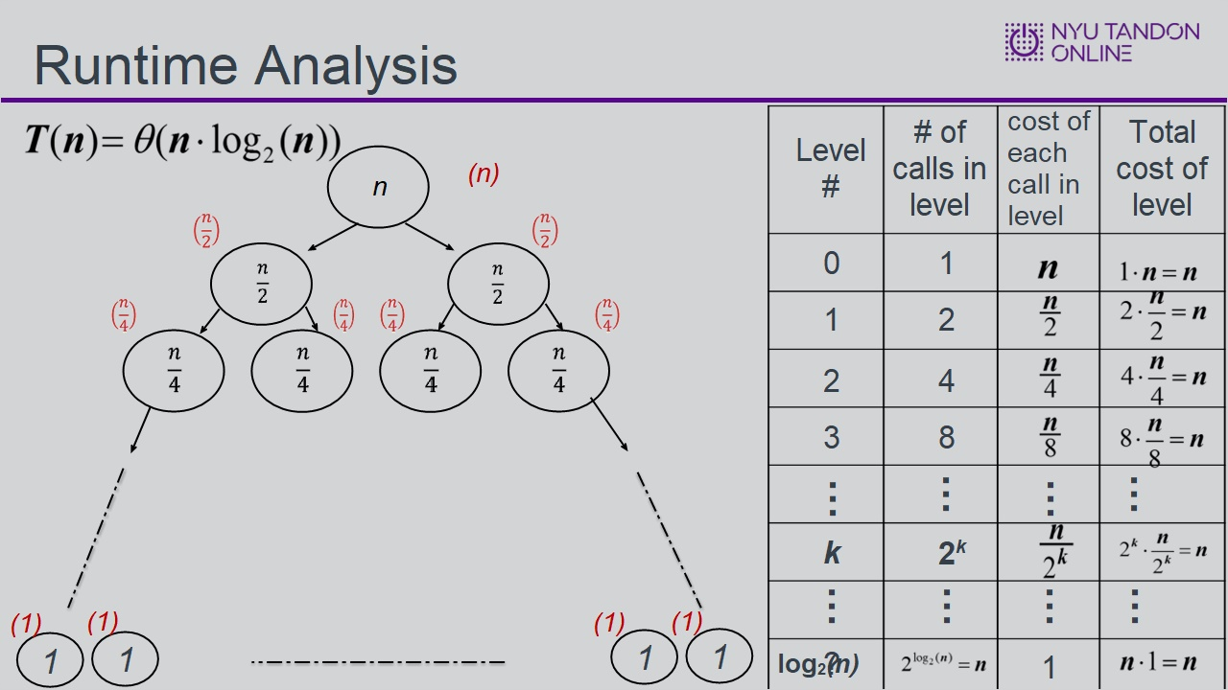

3.7 Knowledge Check
(Sequence Drag-and-Drop, 10 points, 3 attempts permitted)
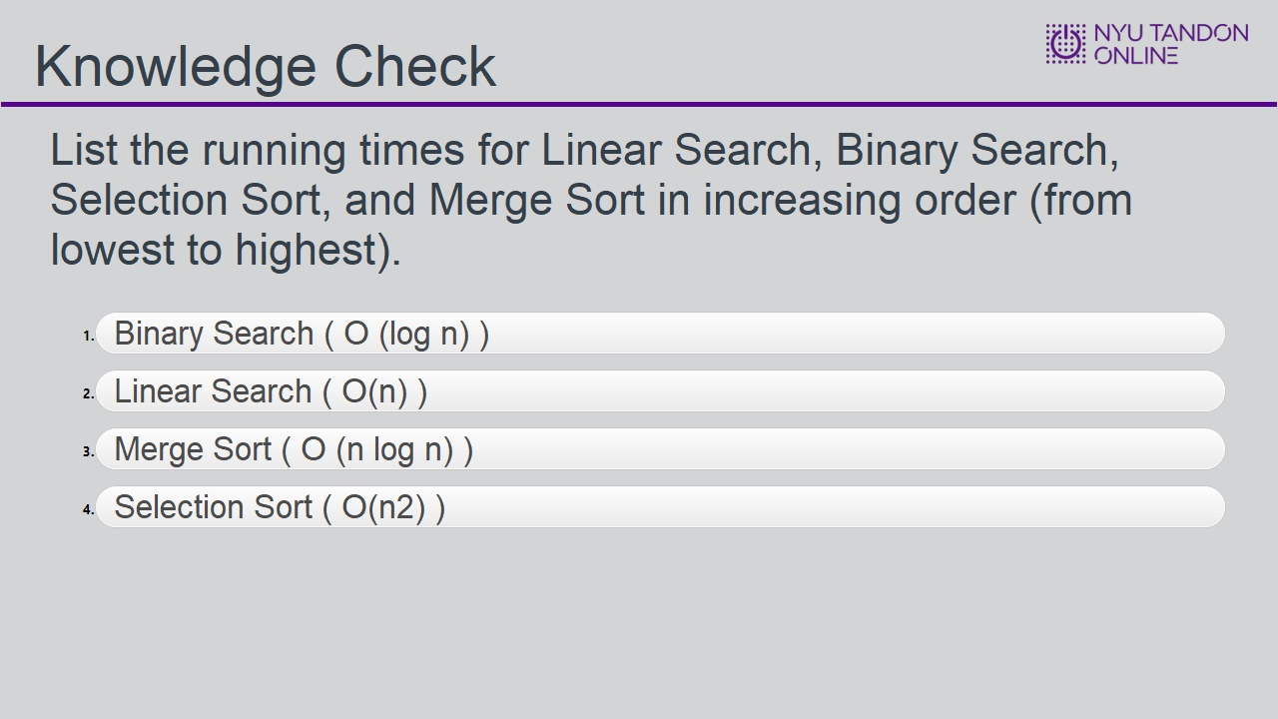
Correct Order
Binary Search ( O (log n) )
Linear Search ( O(n) )
Merge Sort ( O (n log n) )
Selection Sort ( O(n2) )
Feedback when correct:
That's right! You selected the correct response.
Feedback when incorrect:
You did not select the correct response.

Correct (Slide Layer)
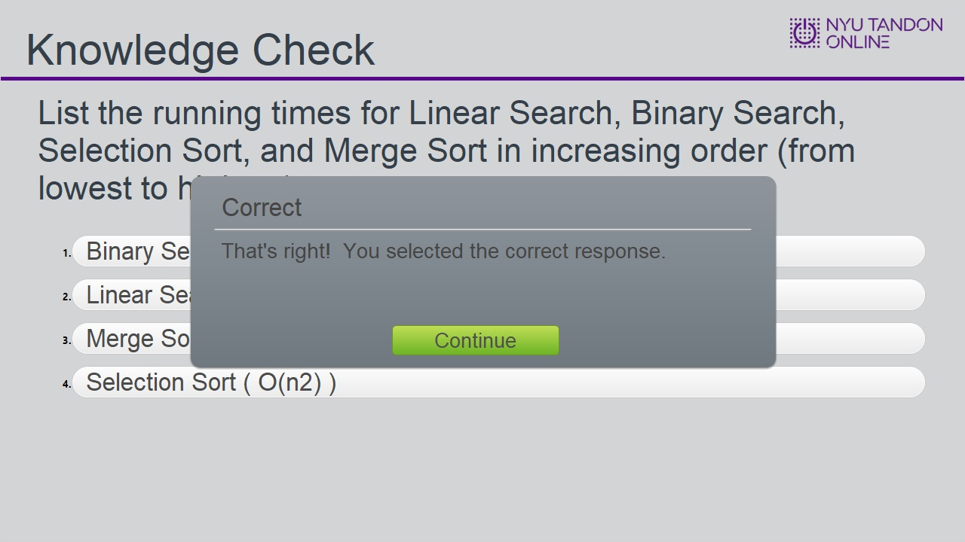

Incorrect (Slide Layer)
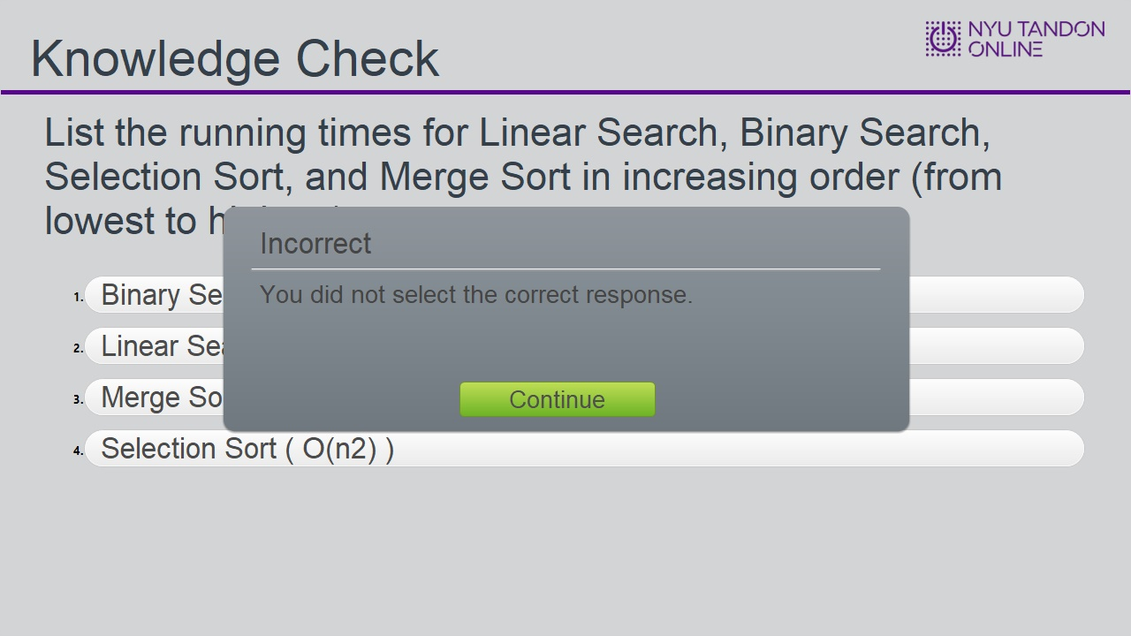

Try Again (Slide Layer)
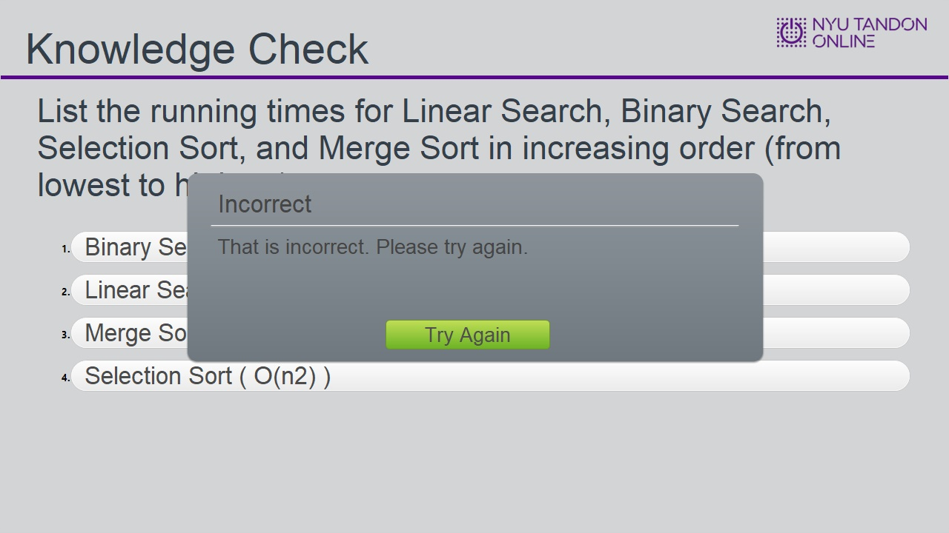

3.8 Knowledge Check
(Matching Drag-and-Drop, 10 points, 2 attempts permitted)
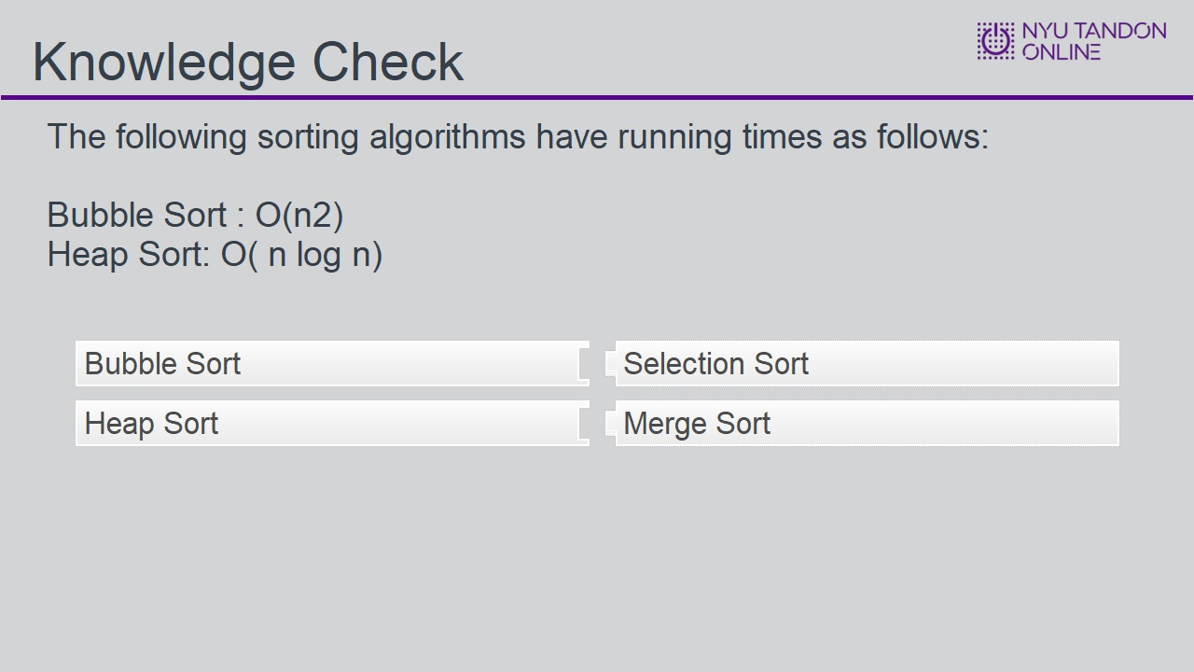
Correct | Choice
Bubble Sort | Selection Sort
Heap Sort | Merge Sort

Feedback when correct:
That's right! You selected the correct response.
Feedback when incorrect:
You did not select the correct response.

Correct (Slide Layer)
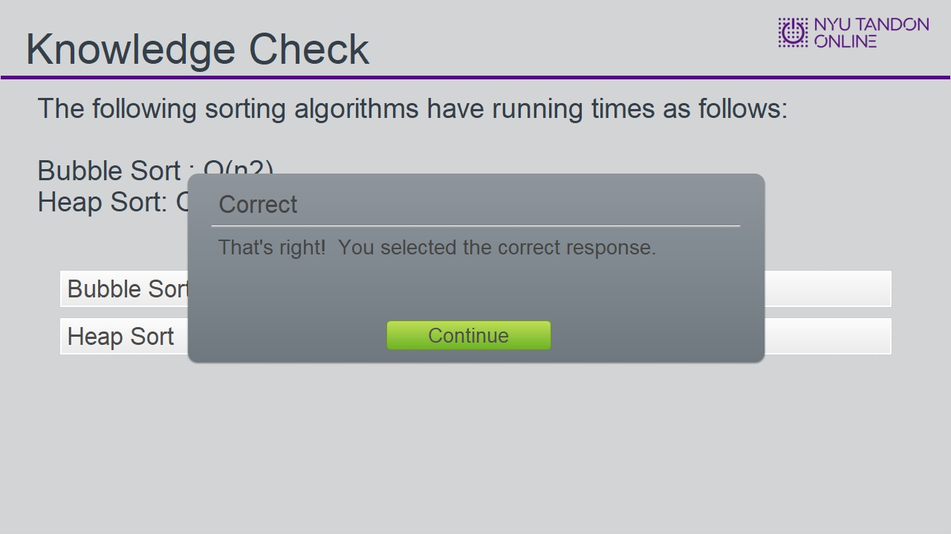

Incorrect (Slide Layer)
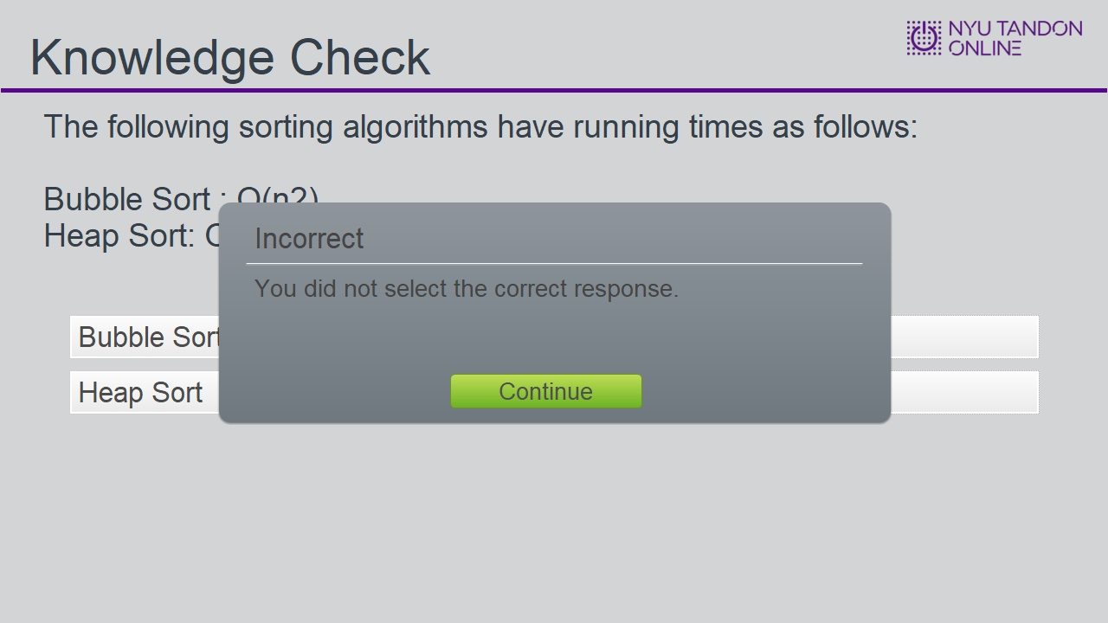

Try Again (Slide Layer)
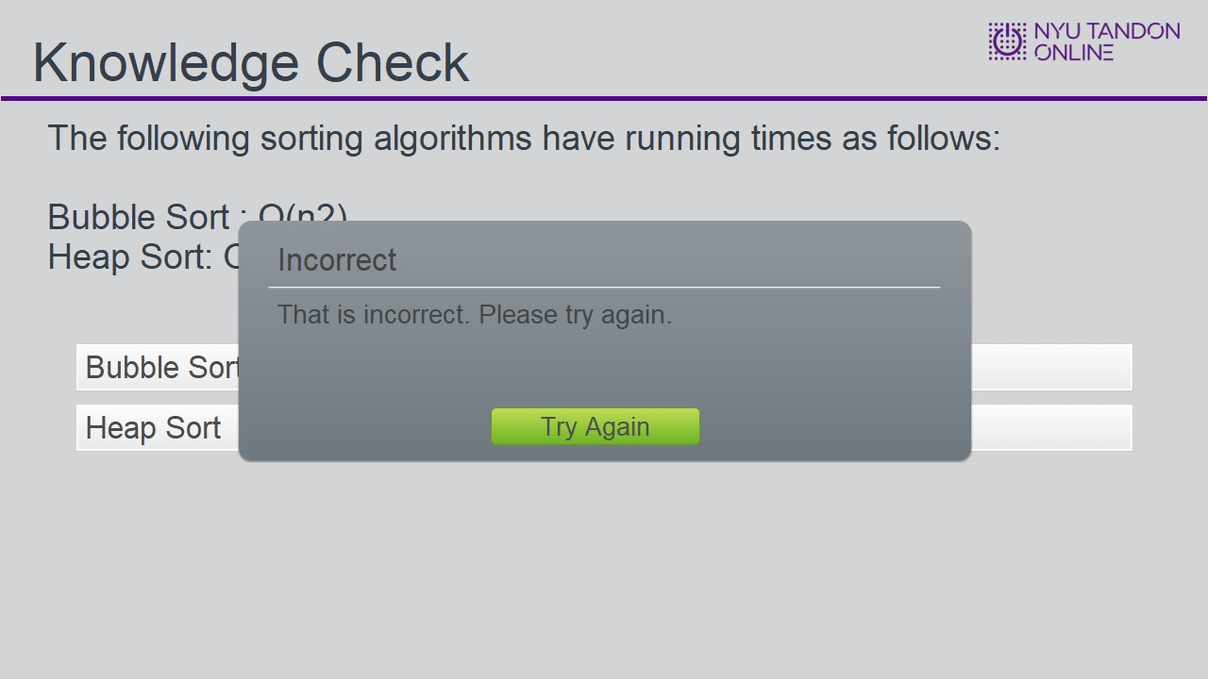

3.9 End of Module


